Sección 1
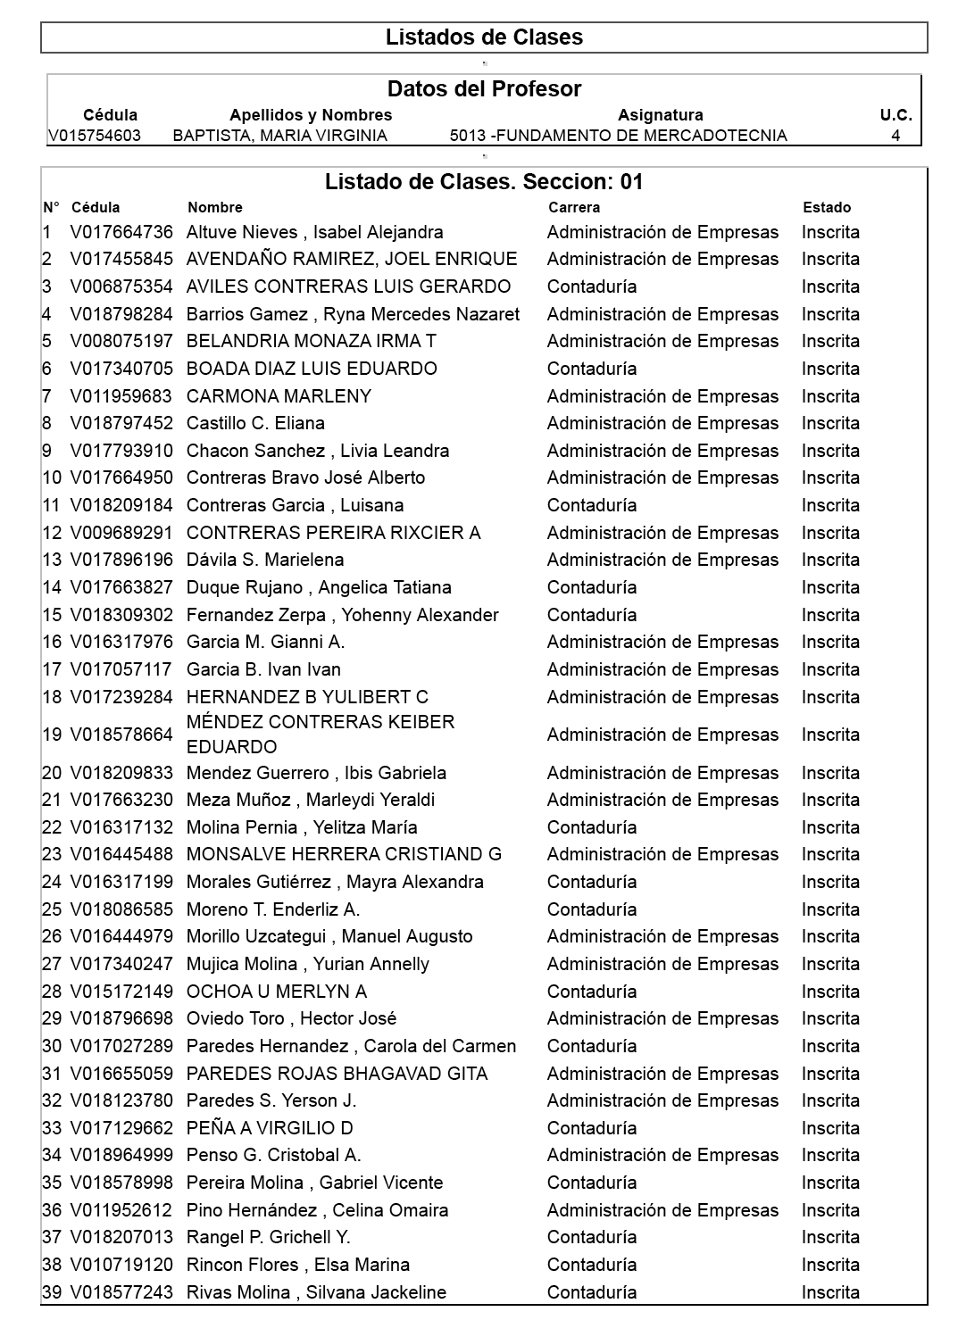

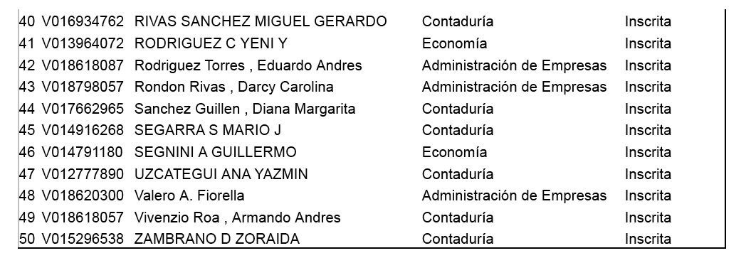

Correo-e:
Nombre | Correo electrónico
Ana Yasmin Uzcategui | anayasmin75@gmail.com
Marleny Carmona | marleny_119@hotmail.com
Yeliytza Molina | yelitza_yossue@hotmail.com
Ryna Barrios | ryna_718@hotmail.com
Celina Pino Hernandez | celina_pino@yahoo.com
Avendaño Joel | enrique_joel@hotmail.com
Miguel Gerardo Rivas | mrivas83@hotmail.com
Leidy Bermudez | princesa2001@hotmail.com
Gianni Garcia | garciagianni@hotmail.com
Silvana Rivas | silvana_rivasmolina@hotmail.com
Diana Guillen | dianac_guillenq@hotmail.com
Eduardo Rodriguez | L_P_M_nova@hotmail.com
Yeni Rodriguez | yomariani@hotmail.com
Maria Andreina Araque | nina19_220@hotmail.com
Enderliz Moreno | enderliz@hotmail.com
Yohenny Fernandez | alexander_ula@hotmail.com
Eliana Castillo | elianacc2@gmail.com
Gabriel Pereira | gabrielpereira635@hotmail.com
Mayra Morales | aryam84@gmail.com
Virgilio Peña | jevpeal_777@hotmail.com
Hector del Castillo | hectoralejandro19@hotmail.com
Armando Vivenzio | armandovivenzio1@hotmail.com
Carolina Baron | Krob70@hotmail.com
Hector Oviedo | hectortyco@hotmail.com
Cristiand Monsalve | cristianmonsa10@hotmail.com
Diana Sanchez | superdianita1@hotmail.com
Mario Segarra | mario2sj@gmail.com
Frank Duque | guayandino74@yahoo.es
Daray Rondon | Darcy_rondon1@hotmail.com
Cristobal Penso | cristobalpensog@hotmail.com
Marleydi Meza | marleydi85@hotmail.com
Yurian Mujica | yuri215@gmail.com
Ibis Mendez | ibisg21@hotmail.com
Livia Chacon | leandra24_2@hotmail.com
Carola Paredes | cacedy5@hotmail.com
Elsa Rincon | dptoeco@ula.ve
Leicy Gonzales | leiycio@hotmail.com
Merlyn Ochoa | nubes8@hotmail.com
Aviles Luis | luisavicon@yahoo.es

Sección 3
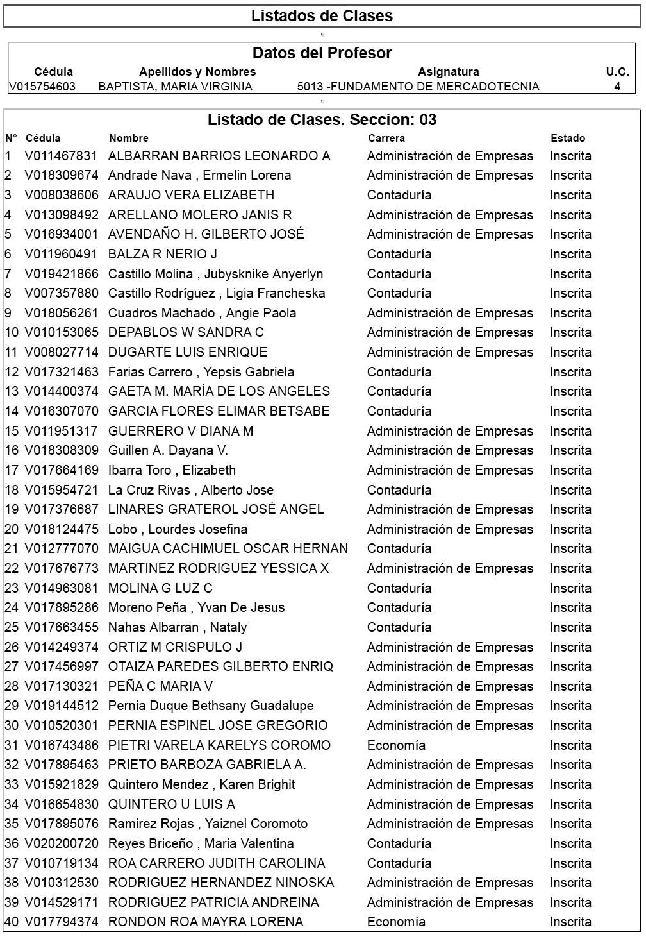

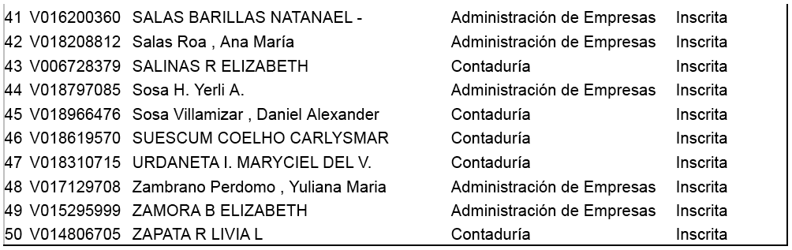

Correo-e:
Nombre | Correo electrónico
Andrade Nava Ermeli Lorena | lorenita17_21@hotmail.com
Ramirez Yaiznel | laflaca760@hotmail.com
Lobo Lourdes | gringd17_187@hotmail.com
Carlysmar Siescum Coelho | carlysmar21@hotmail.com
Yessica Martinez | yessica0309@gmail.com
Andreina Dugarte Calderon | andreinadugarte_24@hotmail.com
Carlos Carrasquero | carrasquero09@gmail.com
Natanael Salas | natanael_salas@hotmail.com
Edgar Flores | cosio131@hotmail.com
Pernia Espinel Jose | perniaespinel2@gmail.com
Arellano Molero Janis | Janisruthmary@hotmail.com
Elizabeth Salinas | elizabeth@ula.ve
Roa Carrero Judith | karola_307@hotmail.com
Zoraida Zambrano | zoraidazzambranodavila@hotmail.com
Guillen Dayana | cosita24005@hotmail.com
Otaiza Gilberto | geop14@hotmail.com
Nataly Nahas | naty7855@hotmail.com
Oscar Maigua | maigua_927@hotmail.com
Ibarra Elizabeth | elizatibarratoro@hotmail.com
Yvan Moreno | ymorenopea@hotmail.com
Gaeta Maria | maria_gae@hotmail.com
Gabriela Farias | Yepsis@hotmail.com
Karen Quintero | brighit_1120@hotmail.com
Ligia Castillo | Argenis11@msn.com
Daniel Sosa | Vieri_Italia@hotmail.com
Crispulo Ortiz | cjom11@hotmail.com
Pernia Bethsany | Bethsany@hotmail.com
Linares Jose Angel | jalgcs@gmail.com
Diana Guerrero | ana_mile21@hotmail.com
Patricia Rodriguez | patriciarodriguez.1@hotmail.com
Sandra Depablos | Depsan56@hotmail.com

