Positive and negative entropy production in thermodynamics systems
José Iraides Belandria
Escuela de Ingeniería Química, Universidad de Los Andes, Mérida, Venezuela
joseiraides @ ula.ve

Abstract
This article presents a heuristic combination of the local and global formulations of the second law of thermodynamics that suggests the possibility of theoretical existence of thermodynamic processes with positive and negative entropy production. Such processes may exhibit entropy couplings that reveal an unusual behavior from the point of view of conventional thermodynamics.
PACS. 05.70. Ln Non equilibrium and irreversible thermodynamics; PACS. 05.70. - a Thermodynamics; PACS. 65.40. gd Entropy.

1. Introduction
The second law of thermodynamics is a monumental law of science explained in most of the undergraduate and graduate textbooks of physics and related fields. There are many ways to articulate this law. However, the local and global formulations of the second law of thermodynamics are very common and useful for practical purposes.
Historically, the global formulation of the second law of thermodynamics is a consequence of the outstanding works of Clausius and other thermodynamics researchers of the nineteenth century. The global formulation expresses the second law in terms of the variation of the total entropy of the universe ${dS}_{u}$ which should be equal or greater than zero [1, 2, 3, 4, 5]. It is zero when the transformations in the universe are reversible and it is greater than zero when irreversible events occur. This proposition can be represented by the following equation
${dS}_{u}$ $≥0$ (1)
According to classical thermodynamics, the variation of the total entropy of the universe is an additive contribution of the change of entropy of the different parts that integrate the universe which may be consider constituted by the system and its surroundings. Therefore, the variation of entropy of the universe ${dS}_{u}$ is equal to the change of entropy of the system ${dS}_{s}$ plus the change of entropy of the surroundings${dS}_{a}$, hence
${dS}_{u} = {dS}_{s} +{dS}_{a}$ (2)

Following the history, by the middle of the XX century, Prigogine [1] postulates the local formulation of the second law of thermodynamics by expressing that the variation of entropy of a system $dS$ is equal to the entropy flow due to the interactions with the surroundings $d_{e}S$ plus the internal entropy production $d_{i}S$ caused by changes inside the system. Thus,
$dS=d_{e}S +d_{i}S$ (3)
. According to Prigogine, the production of internal entropy is equal or greater than zero. It is zero when the processes in the system are reversible and it is greater than zero if the system is subjected to irreversible process. Prigogine proposes, axiomatically, that the destruction or absorption of internal entropy in a part of a system, compensated by an enough production in another region outside of the system is prohibited.
Now, when we combine the global and local formulations of the second law of thermodynamics in a unified version, appears a new vision of the world that insinuates the possibility of existence of processes with positive and negative entropy production. This is a suggestive and remarkable point of view that may be of interest and curiosity to instructors and undergraduate or graduate students of physics and engineering. The objective of this work is to combine both formulations in a creative way to show some interesting conclusions about the possibility of internal entropy production and destruction.

2. Example
As an illustration of this behavior we shall consider the process schematized in figure 1 in which two tanks A and B are separated by a good heat conducting metallic partition covered initially by an adiabatic film. Each tank contains 1 mol of a monatomic ideal gas. The initial pressure and temperature in tanks A and B are $P_{1A} ,$ $T_{1A}$ and $P_{1B}$ ${, T}_{1B }$, respectively. Also $T_{1A} < T_{1B} .$ Both tanks, including the piston, are externally covered by an adiabatic wall. To simplify the analysis it is assumed that the heat capacities and the mass of the walls of both tanks and of the metallic partition are negligible.
To begin the process, the adiabatic film is removed and the heat flows from tank B toward tank A because $T_{1A} < T_{1B}$ . During the process tank B stays at constant volume, and the heat transferred to tank A is used to carry out an isothermal expansion at $T_{1A }$. The process concludes when thermal equilibrium between both tanks is reached which happens when the final temperature in tank B reaches a value $T_{2B }$ equal to${ T}_{1A }$. In this equilibrium state the final pressures in tanks A and B are $P_{2A, }{ P}_{2B}$ , respectively. Since the process in tank A is isothermal ${ T}_{1A }= { T}_{2A }={ T}_{A }.$

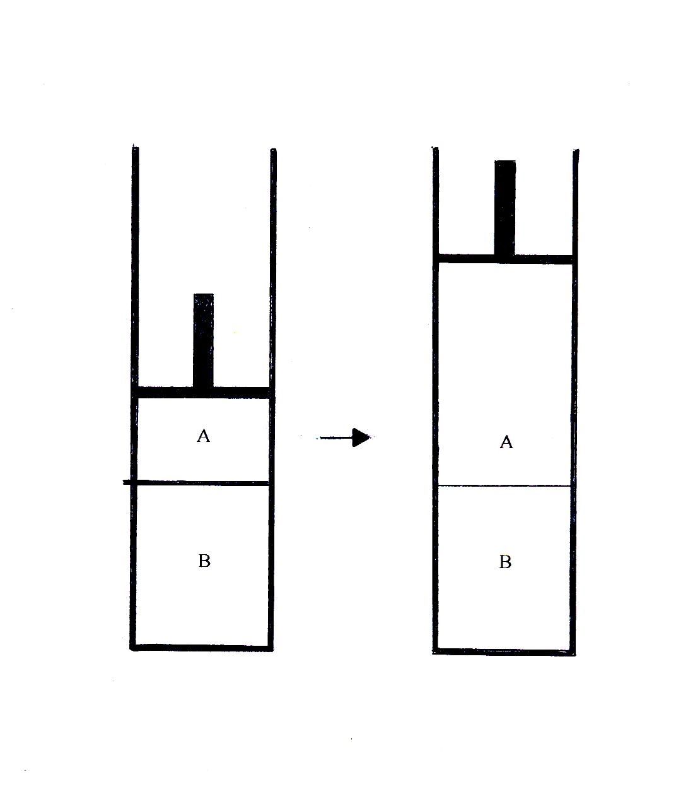
Figure 1. Process with production and destruction of internal entropy

3. Discussion
To start the discussion, we will apply the global formulation of the second of thermodynamics to the universe of the previous process which is an adiabatic closed universe. By inspection, the universe is constituted by tank A, tank B and the external region of both tanks. Since tanks A and B are closed systems, and their external walls adjacent with the rest of the universe are isolated thermally, then, according to (2), the variation of the total entropy of the universe $dSu$ is
$dSu={dS}_{A}$ $+$ ${dS}_{B}$ (3)
where ${dS}_{A}$ and ${dS}_{B}$ denote the variations of entropy of the ideal gas contained in tanks A and B, respectively. Then, by integrating (3) we obtain the total entropy change of the universe $∆Su$ for the specified change of state of the isothermal expansion in tank A and the constant volume process in tank B.
$∆Su= -nR\ln\left(P_{2A}/P_{1A}\right)$ $+ nCv$ $\ln\left(T_{2B}/T_{1B}\right)$ (4)
here, n, $R$ and $Cv$ are the ideal gas moles number, the ideal gas constant and the ideal gas heat capacity at constant volume , respectively.
To carry out some calculations let us assume that $n=1$ mole, $P_{1A} =4$ bar, $P_{2A }$ $=1. 8 bar,$ $P_{1B} =4$ bar and $T_{1B }= 800$ K. From the statement of the problem, ${ T}_{2B }$ , the final temperature in tank B , is not defined previously, but we may know the range of permissible values allowed by the global formulation of the second law of thermodynamics. The permitted values for ${ T}_{2B }$ are those for which ΔSu ≥ 0. Then, according to (4)
${ T}_{2B } ≥ T_{1B }{{ (P}_{2A}/P_{1A}) }^{R/Cv}$ (5)
Therefore, for the proposed conditions $469.784$K $≤{ T}_{2B }<800$K . Since${ T}_{2B }={ T}_{A }$, follows $469.784$K $≤{ T}_{A }<800$K.
In order to analyze the behavior of the process in the above range of temperatures it is instructive to combine the global and local formulation of the second law of thermodynamics. Proceeding in this way, we can extend the underlying ideas of the local formulation of the second law to the whole universe of the process constituted by the system and its surroundings. In other words, we can say that the variation of the total entropy of the universe ${dS}_{u}$ is equal to the entropy flow due to the interactions with the exterior of the universe${ d}_{e}Su$ plus the production of internal entropy due to the irreversibility taking place inside the universe$d_{i}Su$. Then,
$dSu=d_{e}Su +d_{i}Su$ (6)
Now, by applying the local formulation to tanks A and B, we get
$dS_{A}$ $=$ $d_{e}S_{A}+d_{i}$ $S_{A}$ (7)
and
$dS_{B} = d_{e}S_{B}+d_{i} S_{B}$ (8)
In above equations the term $d_{e}S_{A}$ represents the entropy flow due to the interactions of tank A with tank B and $d_{e}S_{B}$expresses the entropy flow associated with the interactions of tank B with tank A. The characters $d_{i}$ $S_{A}$ and $d_{i} S_{B}$ express the production of internal entropy due to the irreversibility inside tanks A and B , respectively.
By combining (1), (3), (6), (7) and (8), we obtain
$dS_{u }=d_{e}Su +d_{i}Su =dS_{A}+dS_{B}= d_{e}S_{A}+d_{i}S_{A} +$ $d_{e}S_{B}+d_{i} S_{B}$ $≥$ 0 (9)
Since the universe and tanks A and B are closed the entropy flow expressions $d_{e}Su$, $d_{e}S_{A}$, $d_{e}S_{B}$reduce to the following equations[1]
$d_{e}Su=dQu/Tu$ $=0$ (10)
here $Qu$ represents the heat flow transferred from the exterior of the universe which is equal to zero because the universe is adiabatic. $Tu$ is the temperature of the universe.
$d_{e}S_{A}=dQ_{A}$ $/T_{A}$ (11)
where $Q_{A}$ is the heat received by tank A from tank B and ${ T}_{A}$ is the temperature of tank A.
${ d}_{e}S_{B}=dQ_{B}$ $/T_{B}$ (12)
here $Q_{B}$ is the heat received by tank B from tank A and ${ T}_{B}$ is the temperature of tank B.
Combination of (9), (10), (11) and (12) gives
$dS_{u }=d_{i}Su =dS_{A}+dS_{B}= (dQ_{A}$ $/T_{A}$ $+ dQ_{B}$ $/T_{B})+d_{i}S_{A} +d_{i} S_{B}$ $≥$ 0 (13)
Evidently, the term $(dQ_{A}$ $/T_{A}$ $+ dQ_{B}$ $/T_{B}$) represents the production of internal entropy $d_{i}S_{h}$due to the flow of heat between tanks A and B. But, from the first law of thermodynamics $dQ_{B}= -$ $dQ_{A}$, then
$d_{i}S_{h} = (dQ_{A}$ $/T_{A}$ $+ dQ_{B}$ $/T_{B}) = dQ_{A} ( 1$ $/T_{A}$ $- 1$ $/T_{B})$ (14)
As a reference, Prigogine [1] deduces an expression similar to this equation for the entropy production due to the irreversible flow of heat among two phases maintained at different temperatures.
After combination of (14) and (13), we obtain
$dS_{u }=d_{i}Su =dS_{A}+dS_{B}= d_{i}S_{h}+d_{i}S_{A} +d_{i} S_{B}$ $≥$ 0 (15)
According to the global formulation of the second law of thermodynamics, if the total entropy change of the universe$dS_{u }$ is equal or greater than zero the process may be possible, independently of the sign, positive or negative, that each internal entropy production terms of equation (15) may have. Under this consideration, the destruction or absorption of internal entropy in a universe integrated by different systems and surroundings could be possible. This may suggest the possibility of existence of internal entropy couplings involving interactions between the different systems that compose a specific universe. If these processes could happen, they would present an unusual behavior as it is described in the following paragraphs.
Now, by substituting, combining and integrating (7), (8), (11), (12), (14) and (15), we obtain the entropy production terms for the changes of states taking place in the process depicted in figure 1.
$∆iS_{A }= -R\ln{ (} P_{2A }/P_{1A})- Q_{A}/T_{A}$ (16)
$∆iS_{B }= Cv\ln{(T_{2B}/T_{1B}})-Cv\ln{(T_{2B}/T_{1B}})= 0$ (17)
$∆iS_{h }$ $=$ $Q_{A}/T_{A}+Cv\ln{(T_{2B}/T_{1B}})$ (18)
$∆iSu=$ $-R\ln{ (} P_{2A }/P_{1A})$ $+Cv\ln{(T_{2B}/T_{1B}})$ (19)
here, $∆iS_{A }$ , $∆iS_{B }$ , $∆iS_{h }$ and $∆iSu$ are the internal entropy production during the specified change of state for tank A, tank B, for the heat flow between both tanks and for the universe of the process, respectively.
Returning to the allowed final temperatures for tank B, we find that the process may be possible if $469.784$ K $≤$ ${ T}_{2B }<800$K. We now can detect that in the range $522.077$ K $<{ T}_{2B }<800$ K the entropy production in tank A is positive, and the entropy production in tank B is zero. Also, the entropy production due to the heat flow between tanks A and B is positive. For example, let us consider the case when ${ T}_{2B }= { T}_{A}=550$ K. For this specific condition $∆iS_{A }=0.970$JK⁻¹, $∆iS_{B }=0$JK⁻¹ , $∆iS_{h }=0.996$ JK⁻¹ and $∆Su=$ $∆iSu=1.966$JK⁻¹ . As a consequence, in the above range of temperatures, the process behaves according to the expectative of the global and local formulations of the second law of thermodynamics.
As a matter of interest, the work${ W}_{A}$ obtained from the isothermal expansion of tank A can be calculated in the above range of temperatures. To carry out this calculation, we assume that the work done by the system is positive and that the heat received by the system is also positive. Is it convenient to indicate that the external pressure $Pext$ of tank A is not known, then we are not able to calculate the work $W_{A}$ using the conventional expression $W_{A}$ $=\int{Pext dV}$ , where $V$ is the volume of the system. However, we can estimate it by applying the first law of thermodynamics to the processes that happen in tanks A and B. Thus
$W_{A}=Q_{A}=-{ Q}_{B} =- Cv({ T}_{2B }-{ T}_{1B })$ (20)
For the case shown above at ${ T}_{2B }= { T}_{A}=550$ K and ${ T}_{1B }=800$ K, we find $W_{A}=3117.750$ J Since the initial temperature in tank B is 800 $K$ and the isothermal expansion in tank A takes place at $550 K$ , then the process is irreversible. At this point, it is illustrative to compare this irreversible work with the value obtained for a reversible isothermal expansion between the same change of state. Under reversible operation, the work $W_{AR}$produced by the isothermal expansion in tank A is $W_{AR}$ $=R { T}_{A}\ln{(}P_{2A }/P_{1A})= 3651.336$ J. Then according to conventional thermodynamics, the work done by the proposed irreversible transformation $W_{A}$ is lower than the reversible work $W_{AR}$ for the same change of state. Thermodynamics explains very well this behavior, arguing that when internal entropy is produced in an irreversible process, the system loses capacity to produce work in comparison with a reversible operation under the same change of state, and, as a consequence, there is some work lost ${ W}_{L}$, which is equal to the difference between the reversible work $W_{AR}$ and the irreversible work $W_{A}$ or
${ W}_{A}=W_{AR}-$ $W_{L}$ (21)
If we combine (16 ) and (20 ) , the following equation results
$W_{A}=$ $R { T}_{A}\ln{(}P_{2A }/P_{1A}){ - T}_{A}∆iS_{A }$ (22)
By combining (21) and (22) we get
${ W}_{L}$ ${= T}_{A}∆iS_{A }$ (23)
for the proposed example, ${ W}_{L}$ ${= T}_{A}∆iS_{A }=533.5$J , approximately.
On the other hand, when 469.784 K ${≤ T}_{2B }< 522.077$ K , the entropy production due to the heat flow between tanks A and B is positive, the entropy production in tank B is zero, but the entropy production in tank A is negative. However, this range of temperatures is allowed by the global formulation of the second law of thermodynamics because the variation of entropy of the universe ${dS}_{u}$ and the total entropy production of the universe $∆iSu$ are greater than zero. For example, if ${ T}_{2B }$= $T_{A}$ = 480 K , we obtain $∆iS_{A }= -1.675$ JK⁻¹, $∆iS_{h }=1.943$JK⁻¹ , $∆iS_{B }=$ 0 JK⁻¹ and $∆Su$ = $∆iSu=$0.268 JK⁻¹. From (20) the work $W_{A}$ obtained for the isothermal expansion in tank A is 3990.720 J . Since${ T}_{1B }=800$ K and ${ T}_{2B }$= $T_{A}$ = 480 K , this process is irreversible. We can compare this irreversible work with the work of a reversible isothermal expansion taking place between the same initial and final state$W_{AR}$ $=R { T}_{A}\ln{(}P_{2A }/P_{1A})=3186.621$J. We observe that the work $W_{A}$ executed by the proposed irreversible transformation is greater than the reversible work$W_{AR}$ for the same change of state. This result is unexpected from classical thermodynamics. To explain this behavior, we can argument, analogously to the previous case, that the entropy destruction allows to the system to win an additional work ${ W}_{G}$ , and from (22)
${ W}_{A}=W_{AR}+$ $W_{G}$ (24)
and
${ W}_{G}{= - T}_{A}∆iS_{A }$ (25)
In this case ${ W}_{G}=804$ J.
It is also detected that the process can reach a stationary state in which the negative production of entropy is equal to the positive production of entropy, but different from zero. In this circumstance $∆Su=∆iSu=∆iS_{A }$ $+ ∆iS_{B }+∆iS_{h }=0$. This state is reached when ${ T}_{2B }$= $T_{A}$ = $469.784$K. Here, $∆iS_{A }=-2.127$ JK⁻¹ , $∆iS_{h }=2.127$JK⁻¹, $∆iS_{B }= 0$ JK⁻¹. Under this trajectory, the work done by the irreversible isothermal expansion in tank A is $W_{A}=4188.174$J. The corresponding reversible work for the same change of state is $W_{AR}=3188.772$J and the gain work is ${ W}_{G}=999.222$J. As we can see, this trajectory is the most efficient route we can find for the proposed process, and the final state achieved corresponds to a stationary state in which the positive entropy production is compensated, exactly, by the negative entropy production. In this condition, the universe, at constant entropy, operates irreversibly under finite gradients of thermodynamic variables.
In general, following similar procedures, it is possible to design different versions of entropy couplings in closed and open systems operating under isobaric, isochoric, isothermal and adiabatic conditions, among other permissible alternatives [6].

5. Conclusion
To conclude, the combination of the local and global formulations of the second law of thermodynamics suggests the possibility of theoretical existence of irreversible processes with entropy couplings among the different parts of the universe. Such transitions allowed by the combined formulations of the second law of thermodynamics produce unexpected effects from the point of view of conventional thermodynamics as the possibility of being more efficient than a reversible operation under the same change of state. The maximum efficiency of these transformations is obtained when the positive internal entropy production compensates the negative entropy production reaching a stationary state unpredicted by classical thermodynamics. It is convenient to indicate that when the local or the global formulations of the second law of thermodynamics are applied in an independent way it is not possible to predict the entropy couplings analyzed here. Only, a combination of both formulations in the sense proposed in this study suggests this interesting possibility.

References
[1] Prigogine I 1967 Thermodynamic of Irreversible Processes ( New York : Interscience Publishers)
[2] Smith J M and Van Ness H C 1975 Introduction to Chemical Engineering Thermodynamics ( New York : McGraw Hill Book Company)
[3] Halliday D and Resnick R 1970 Fundamentals of Physics (New York : John Wiley and Sons, Inc.)
[5] Perrot P 1988 A to Z of Thermodynamics ( New York : Oxford University Press Inc.)
[6] Belandria JI 2005 Positive and Negative entropy production in an ideal gas expansion Europhys.Lett., 70(4) 446-451

